**STATIC ROUTING**

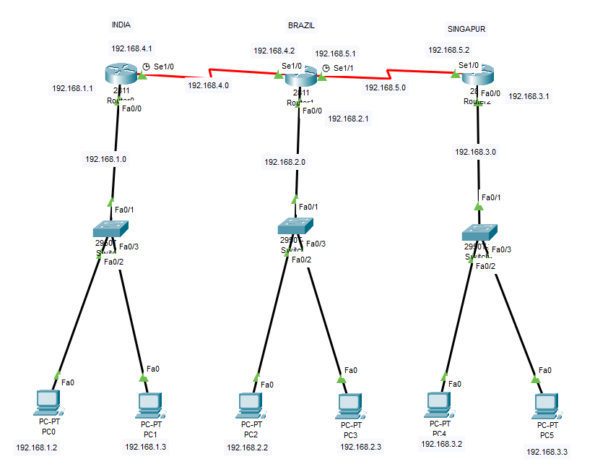

For Router 0

Router#conf t

Router(config)#int se1/0

Router(config-if)#ip address 192.168.4.1 255.255.255.0

Router(config-if)#no shut

Router(config-if)#int f0/0

Router(config-if)#ip add

Router(config-if)#ip address 192.168.1.1 255.255.255.0

Router(config-if)#no shut

For Router 1

Router(config)#int se 1/0

Router(config-if)#ip address 192.168.4.2 255.255.255.0

Router(config-if)#no shut

Router(config-if)#int se 1/1

Router(config-if)#ip address 192.168.5.1 255.255.255.0

Router(config-if)#no shut

Router(config-if)#int f0/0

Router(config-if)#ip address 192.168.2.1 255.255.255.0

Router(config-if)#no shut

For Router 2

Router(config)#int se1/0

Router(config-if)#ip add

Router(config-if)#ip address 192.168.5.2 255.255.255.0

Router(config-if)#no shut

Router(config-if)#int f0/0

Router(config-if)#ip add

Router(config-if)#ip address 192.168.3.1 255.255.255.0

Router(config-if)#no shut

To configure for sending packets to router 1 and router 2

Router(config)#ip route 192.168.2.0 255.255.255.0 192.168.4.2

Router(config)#ip route 192.168.5.0 255.255.255.0 192.168.4.2

Router(config)#ip route 192.168.3.0 255.255.255.0 192.168.5.2

Router(config)#do wr

To configure for sending packets to router 0 and router 2

Router(config)#ip route 192.168.1.0 255.255.255.0 192.168.4.1

Router(config)#ip route 192.168.3.0 255.255.255.0 192.168.5.2

Router(config)#do wr

To configure for sending packets to router 0 and router 1

Router(config)#ip route 192.168.2.0 255.255.255.0 192.168.5.1

Router(config)#ip route 192.168.1.0 255.255.255.0 192.168.4.1

Router(config)#ip route 192.168.4.0 255.255.255.0 192.168.5.1

Router(config)#do wr

